KOMMURI PRATAP REDDY INSTITUTE OF TECHNOLOGY
Department of Computer Science and Engineering (AI&ML)

PROJECT REVIEW - 3
DOCUMENTATION

Zero-Knowledge Proof Based
Privacy Compliance System
(Blockchain-Based Compliance System)
Submitted by
Name of the Student | Roll Number | Role
K. Prem Kumar | 23RA1A6675 | Team Lead
N. Rakesh Chary | 23RA1A6682 | Team Member
K. Shivamani | 23RA1A66A6 | Team Member
G. Shashank | 23RA1A6693 | Team Member

Under the Guidance of
Dr. M. Chalapathi Rao
Department of AI&ML, KPRIT

Table of Contents
1. Introduction and Overview of UML Design 3
2. Use Case Diagram 4
3. Activity Diagram – Compliance Verification Workflow 5
4. Sequence Diagram – ZK Compliance Verification 6
5. Class Diagram – Core Domain Model 7
6. Component Diagram – System Components 8
7. Deployment Diagram – System Deployment 9
8. State Machine Diagram – Consent and Compliance Lifecycle 10
9. Conclusion 11

1. Introduction and Overview of UML Design

This document presents the software design of the “Zero-Knowledge Proof Based Privacy Compliance System”, prepared from the UML Design presentation. The project is carried out by the students of the Department of Artificial Intelligence and Machine Learning, Kommuri Pratap Reddy Institute of Technology (KPRIT), under the guidance of Dr. M. Chalapathi Rao.
The earlier reviews defined the problem, the approach and the architecture of the system. This review models the same system using the Unified Modeling Language (UML). UML gives a standard, visual way to describe who uses the system, how work flows through it, how its objects relate to each other, how its parts are built and deployed, and how its data changes state over time.
The presentation uses eight UML diagrams. Each one looks at the system from a different angle, and together they give a complete picture of its structure and behaviour. Table 1 lists the diagrams and the question each answers.
Table 1: UML diagrams used in the design
No. | Diagram | Category | Question Answered
1 | Use Case Diagram | Behaviour | Who uses the system and for what?
2 | Activity Diagram | Workflow | What steps does a compliance check go through?
3 | Sequence Diagram | Interaction | In what order do the parts exchange messages?
4 | Class Diagram | Structure | What are the core objects and how are they related?
5 | Component Diagram | Architecture | What software components make up the system?
6 | Deployment Diagram | Deployment | Where does each part run, and how are they connected?
7 | State Machine Diagram | Lifecycle | Which states do consent and compliance pass through?

The presentation labels its eight slides as UML, Workflow, Interaction, Structure, Architecture, Deployment and Lifecycle, along with the title slide. The sections below follow the same order.

1.1 Purpose of the UML Design
- To give the team and the guide a common visual language for the system.
- To check that every actor, process and data item identified earlier has a place in the design.
- To act as the blueprint for implementation of the four modules described in Review II.

2. Use Case Diagram

The use case diagram shows the functions that the system offers and the actors who use them. The system boundary is labelled “Privacy Compliance System”, with two actors outside it: the Data Owner / User and the Regulator / Verifier.
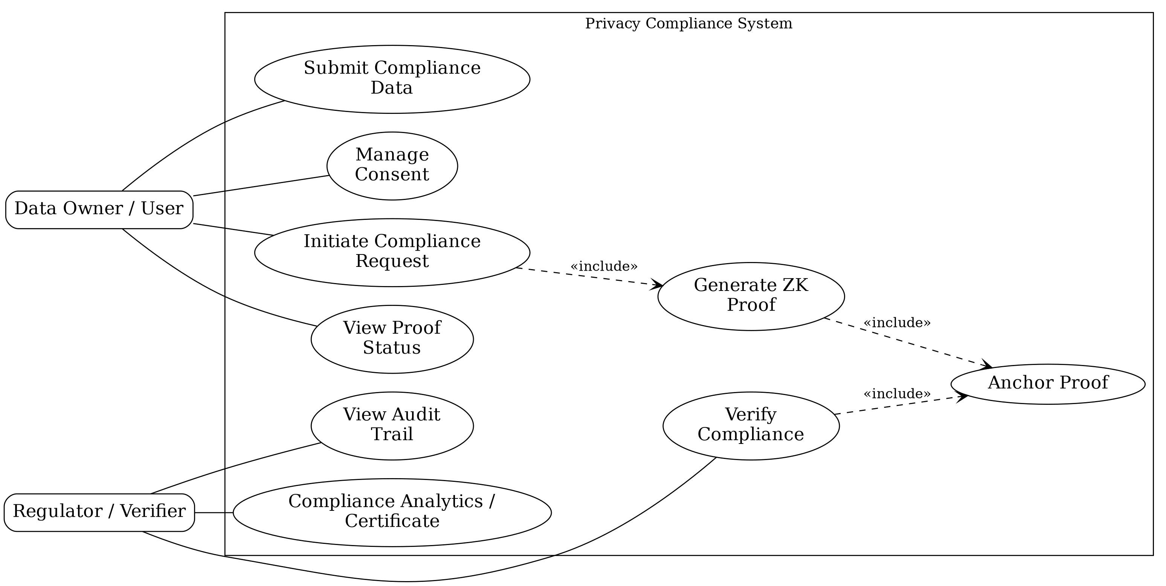
Figure 1: Use case diagram
Table 2: Actors and their use cases
Actor | Use Case | Description
Data Owner / User | Submit Compliance Data | Provides the private data on which a compliance rule is to be proved.
Data Owner / User | Manage Consent | Creates, updates or withdraws consent for data processing.
Data Owner / User | Initiate Compliance Request | Starts a compliance check; this leads to proof generation.
Data Owner / User | View Proof Status | Follows the progress of a submitted proof.
Regulator / Verifier | Verify Compliance | Checks the on-chain attestation for a compliance rule.
Regulator / Verifier | View Audit Trail | Reads the immutable record of compliance checks.
Regulator / Verifier | Compliance Analytics / Certificate | Views analytics and obtains a blockchain-backed certificate.
System (internal) | Generate ZK Proof, Anchor Proof | Included in the actor-facing use cases (dashed arrows); not started by a person.

3. Activity Diagram – Compliance Verification Workflow

The activity diagram shows the flow of control for one compliance check, from the first input to the final result. It contains one decision point, which checks whether the proof is valid.
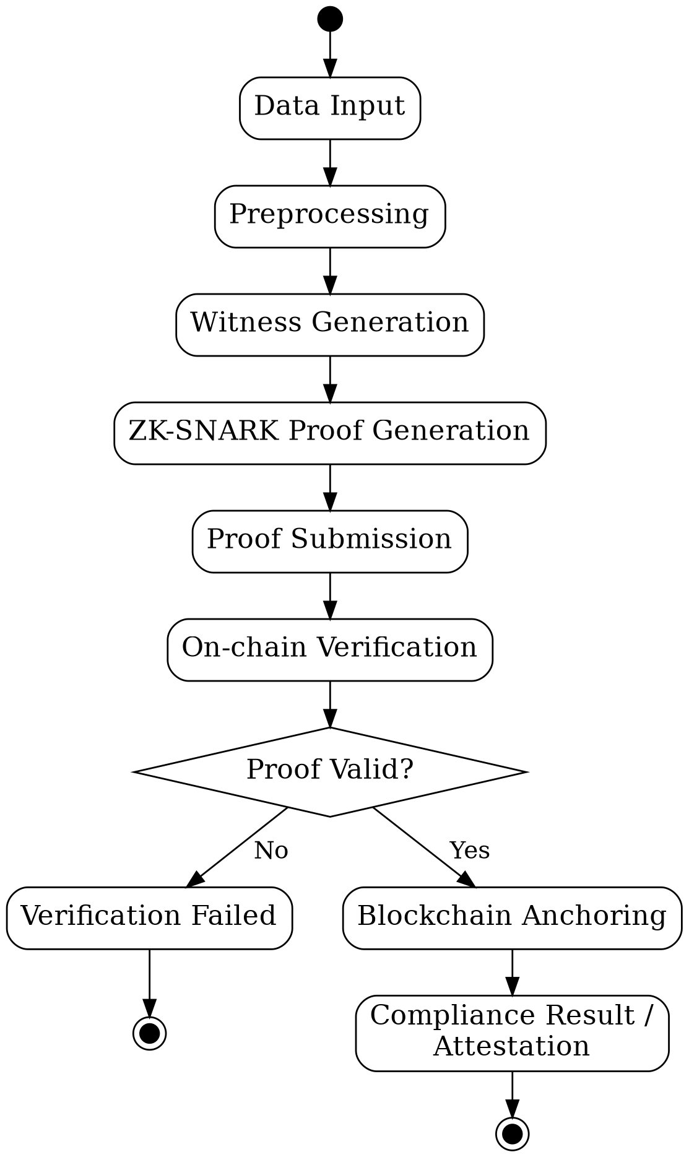  Figure 2: Activity diagram | 1. Data Input: The data owner submits the private compliance data.  2. Preprocessing: Input is validated and the public threshold is set.  3. Witness Generation: A witness satisfying the compliance circuit is computed.  4. ZK-SNARK Proof Generation: The proof is created from the witness.  5. Proof Submission: The proof and public inputs are sent to the smart contract.  6. On-chain Verification: The contract checks the proof.  7. Proof Valid?: Decision: valid proofs continue, invalid proofs stop.  8. Blockchain Anchoring: On success, the result is recorded immutably.  9. Compliance Result / Attestation: The attestation is returned as the final output.

3.1 Outcome of the Decision Point
If the proof is valid, the workflow moves to Blockchain Anchoring and ends with the compliance attestation. If it is not valid, the workflow ends at Verification Failed and nothing is anchored on the chain. In both cases no raw data is revealed.

4. Sequence Diagram – ZK Compliance Verification

The sequence diagram shows the order of messages between seven participants: the Data Owner, React Client, API / Orchestrator, ZKP Engine, Smart Contract, Blockchain Ledger and Regulator. Time runs from top to bottom, and dashed arrows represent return messages. The API / Orchestrator is the centre of the interaction: it alone talks to the ZKP engine, the smart contract and the client, which keeps the other parts independent.
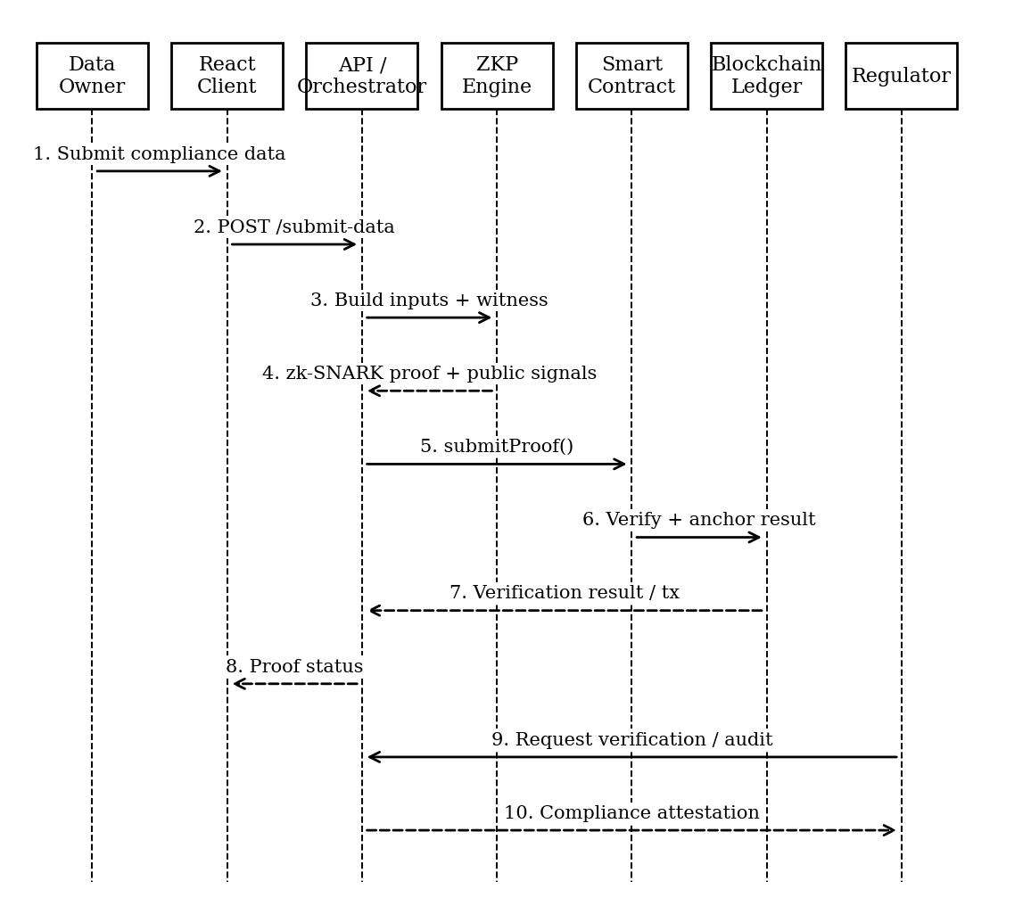
Figure 3: Sequence diagram
- Proof creation: Messages 1 to 4 take the private data from the owner to the ZKP engine and return the zk-SNARK proof with its public signals.
- Verification and anchoring: Messages 5 to 8 submit the proof to the smart contract, anchor the result on the ledger and return the proof status to the client.
- Regulator audit: Messages 9 and 10 let the regulator request an audit and receive the compliance attestation.

5. Class Diagram – Core Domain Model

The class diagram describes the main objects of the system, their attributes and operations. There are seven classes, grouped into the user and consent classes, the proof classes, and the reporting classes.
Table 3: Classes, attributes and operations
Class | Attributes | Operations | Responsibility
User | userId, role, authenticationStatus | authenticate() | Represents a data owner or regulator.
ConsentRecord | consentId, purpose, status, expiryDate | update(), withdraw() | Stores the consent given for a purpose.
ComplianceRequest | requestId, complianceRule, status, createdAt | submit(), validate() | Holds a request to prove a rule.
ZKProof | proofId, proofData, publicSignals, proofHash | generate(), verify() | Holds the proof and its public signals.
VerificationRecord | verificationId, result, timestamp, transactionHash | recordResult() | Records the outcome of verification.
AuditReport | reportId, entityId, dateRange, complianceStatus | generate() | Summarises checks for an entity.
ComplianceDashboard | proofStatus, auditView | verifyStatus(), auditReport() | Presents status and audit data.

5.1 Relationships between the Classes
- User to consent and request. A user can have one or more consent records and can submit one or more compliance requests (multiplicity 1..*).
- Request to proof. A compliance request generates a ZKProof, which is the link between the data owner’s request and the cryptographic proof.
- Proof to verification and audit. A ZKProof is verified and the result is stored as a VerificationRecord. One or more verification records feed an AuditReport (1..*).
- Dashboard. The dashboard reads proof status and audit reports to display them to the regulator.
The privacy design is visible in the model: the proof classes store only proofData, publicSignals and proofHash, and none of the classes stores the private compliance data itself.

6. Component Diagram – System Components

The component diagram shows the seven software components and the dependencies between them.
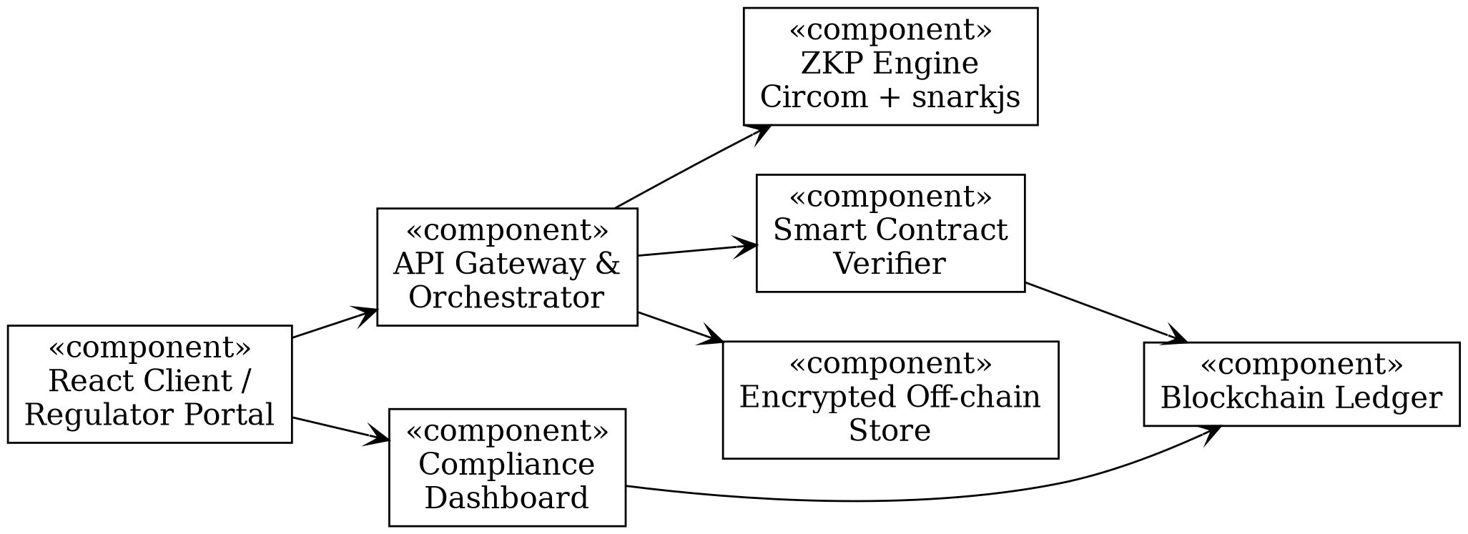
Figure 4: Component diagram
Table 4: System components
Component | Role
React Client / Regulator Portal | User interface for data owners and regulators.
API Gateway & Orchestrator | Receives requests, validates input and controls the proof workflow.
ZKP Engine (Circom + snarkjs) | Builds the circuit, computes the witness and generates the proof.
Smart Contract Verifier | Verifies the submitted proof on-chain.
Encrypted Off-chain Store | Holds private data that must never reach the chain.
Blockchain Ledger | Stores proof hashes and results immutably.
Compliance Dashboard | Shows proof status, audit trail and analytics.

7. Deployment Diagram – System Deployment

The deployment diagram shows the nodes on which the software runs and the protocols connecting them.
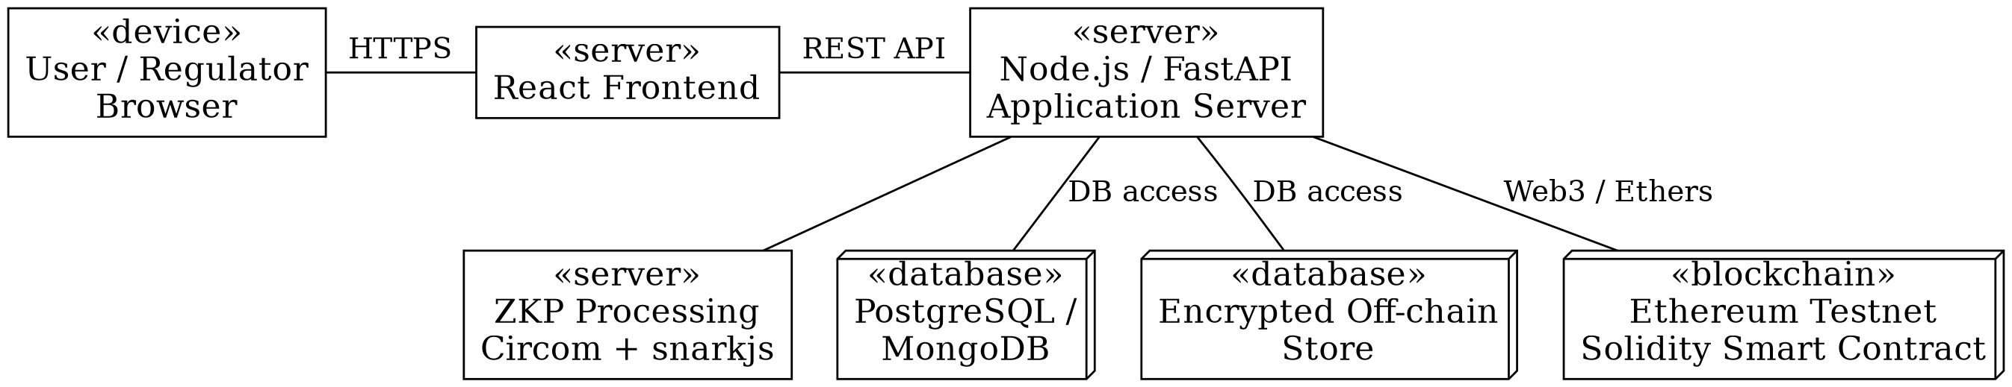
Figure 5: Deployment diagram
- Client side: The browser reaches the React frontend over HTTPS, which calls the application server (Node.js / FastAPI) through a REST API.
- Server and blockchain side: The application server uses the ZKP node, the databases and the encrypted store, and reaches the Solidity smart contract on the testnet through Web3 / Ethers.

8. State Machine Diagram – Consent and Compliance Lifecycle

The state machine diagram follows the life of consent and of a compliance proof. It is shown here in two parts, as consent states and as compliance states.

8.1 Consent States
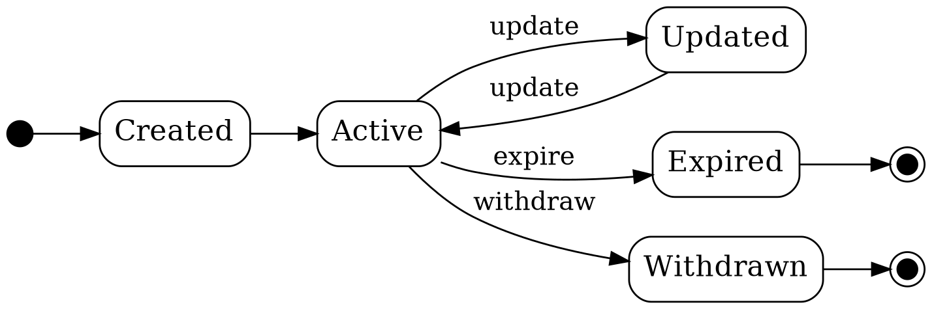
Figure 6: Consent lifecycle

8.2 Compliance States
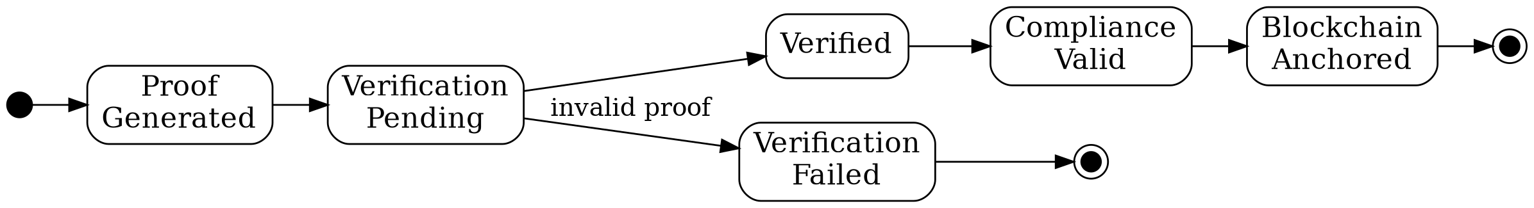
Figure 7: Compliance lifecycle
Table 5: States and transitions
State | Reached By | Meaning
Created / Active | Consent is recorded | Consent is valid and can be used for compliance checks.
Updated | update | Consent terms changed; returns to Active on a further update.
Expired / Withdrawn | expire / withdraw | Consent has lapsed or has been revoked by the owner.
Proof Generated | Proof created | A zk-SNARK proof exists for the request.
Verification Pending | Proof submitted | Waiting for on-chain verification.
Verified / Compliance Valid | Proof accepted | The rule is satisfied.
Blockchain Anchored | Result recorded | The result is immutable on the ledger.
Verification Failed | invalid proof | The proof was rejected; nothing is anchored.

9. Conclusion

The UML design models the Zero-Knowledge Proof Based Privacy Compliance System from every important point of view. The use case diagram sets out the functions of the data owner and the regulator. The activity and sequence diagrams show how a compliance check moves through the system and how the components talk to each other. The class diagram defines the domain model, the component and deployment diagrams describe how the system is built and where it runs, and the state machine diagram describes the lifecycle of consent and compliance.
Taken together, the diagrams show a consistent design in which private data stays in the encrypted off-chain store, proofs are generated by a separate ZKP engine, and the blockchain holds only proof hashes and verification results. This agrees with the architecture and data flow presented in Review II.

9.1 Key Observations
- Every actor-facing use case maps to a step in the workflow and a message in the sequence diagram.
- Each class in the domain model can be traced to a component in the component diagram.
- The lifecycle states cover both the consent given by the user and the proof produced for the regulator.

9.2 Next Steps
- Use the diagrams as the reference for implementing modules M1 to M4.
- Finalise the circuit and complete the testnet deployment.
- Update the diagrams if the implementation changes.

Thank You

